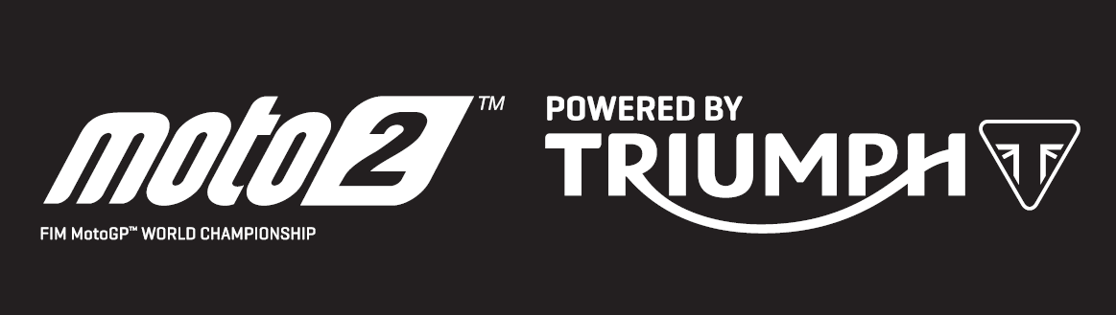
PRESS RELEASE

Triumph triple-powered Moto2™ motorcycles thrill fans across the weekend at German Moto2 GP and Goodwood Festival of Speed

Alex Marquez took a decisive fourth victory of the season in Germany, after scoring his first Moto2™ pole position using Triumph 765cc power. It was a focused display from the EG 0,0 Marc VDS rider, who hit the front on lap seven after dropping to fifth, and then never looked back.

He led home a determined Brad Binder with his best finish of the season and Marcel Schrotter completied the podium. With Luthi only being able to manage fifth place after being handed a long lap penalty for coming together with Xavi Vierge, Marquez heads into the summer break just eight points ahead in the championship race. With just 39 points separating the top six riders, there is still all to play for in the second half of the season.

Meanwhile, the UK played host to the incredible Goodwood Festival of Speed event over the same weekend, and 2 x World Superbike champion James Toseland put on a great show aboard the Triumph 765cc Moto2 engine prototype bike to the delight of 200,000 fans.

Steve Sargent, Triumph’s Chief Product Officer, said: “We said at the start of the season we wanted to help make Moto2 racing close, fast and exciting. Reliving the first half of the season, I really think we have succeeded in this objective. We’ve had some spectacular racing with four different winners and nine different riders standing on the podium. Race and lap records have tumbled and it’s great to see that only 39 points separate the top six riders in the championship after nine races. And it was great to see James Toseland delighting fans at Goodwood on the Moto2 bike exactly a year after we world-debuted this project. Bring on the second part of the year!”

The Triumph Moto2™ 765cc race engine is a development of the class-leading Street Triple RS 765cc road motorcycle and produces more than 140PS and the same visceral soundtrack.

Next up for the Moto2™ series after the season break is the Grand Prix of the Czech Republic on 4 August.
#PoweredByTriumph #TriumphOfficial
ENDS

For further information contact Tom Robinson on Tom.Robinson@Triumph.co.uk
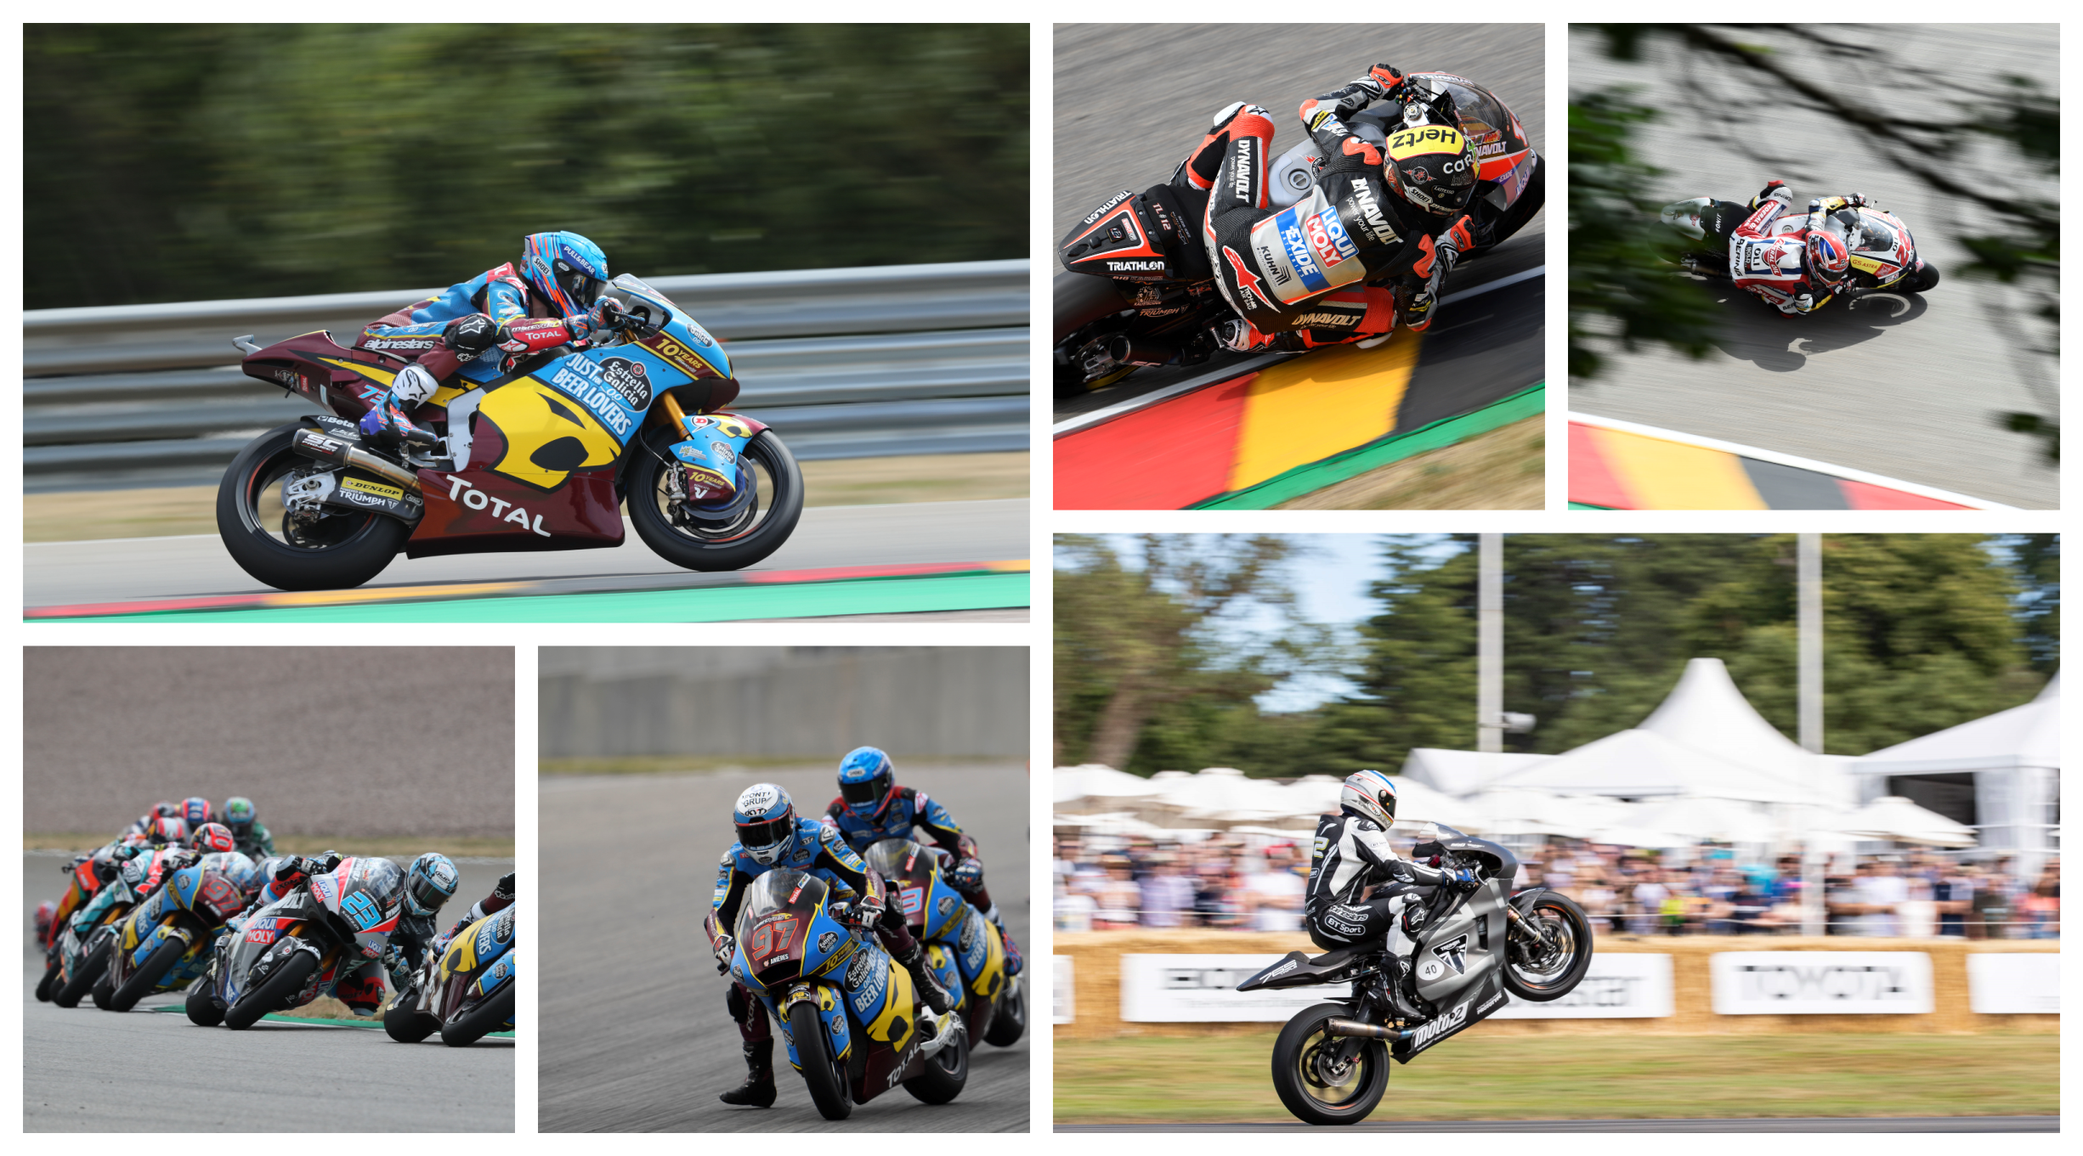
Notes to Editors

- The Triumph Moto2™ 765cc race engine is a development of the class-leading Street Triple RS 765cc road motorcycle and producing more than 140ps and the same visceral soundtrack.
- First established in 1902, Triumph Motorcycles celebrated 110 years of motorcycle manufacture in 2012. For more than three decades, Triumph Motorcycles has been based in Hinckley, Leicestershire, and has produced iconic bikes that perfectly blend authentic design, character, charisma and performance.

- Building around 65,000 bikes per year, Triumph is the largest British motorcycle manufacturer and has around 620 dealers across the world.

- This focus, innovation and engineering passion has today created a broad range of bikes suited to all motorcycle riders, including the iconic new Scrambler 1200, epic Speed Triple, the game changing all new Street Triple 765, the class defining Tiger 800, transcontinental Tiger 1200, iconic Triumph Bonneville family including the stunning Speed Twin, Bonneville Bobber, legendary Thruxton, accessible Street Twin, Street Scramble and iconic Bonneville T120 and T100, plus an exciting and accessible A2 range of Triumph motorcycles

- Triumph currently employs around 2,000 personnel worldwide and has subsidiary operations in the UK, North America, France, Germany, Spain, Italy, Japan, Sweden (Scandinavia), Benelux, Brazil, India and Thailand as well as a network of independent distributors. Triumph has manufacturing facilities in Hinckley, Leicestershire, and Thailand plus CKD facilities in Brazil and India.

- The Triumph Bonneville, famously named to celebrate Triumph’s 1956 land speed record on the Bonneville Salt Flats in Utah, USA, was the original British superbike and a race-winner straight out of the crate. Chosen by famous motorcyclists of the past for its legendary handling, style, and character. It’s that handling, character and style, married to modern rider-focused technology that makes the new Bonneville family THE authentic modern classic choice today.

- Triumph has a glorious racing history, competing in and winning races in almost every class and field of motorcycle sporting achievement. From winning the second ever Isle of Man TT in 1908, through to 1960s road and track domination in Europe and America, right up to contemporary racing achievements with the 675cc Triumph triple powered 2014 Daytona 200 win, the 2014 Isle of Man Supersports TT, 2014 and 2015 British Supersports titles and World SuperSport racing. And now with the new generation of 765cc triple engine powering the 2019 Moto2™ championship, Triumph’s racing legend continues.

